SANSKAAR PATNI
180905134 CSE-C 23

LAB 3

1. Wait
#include <sys/types.h>
#include <unistd.h>
#include <stdio.h>
#include <stdlib.h>
int main()
{
int status;
pid_t pid;
printf("Fork program starting..\n");
pid = fork();
if (pid == -1)
{
perror("Fork Failed");
exit(1);
}
else if (pid == 0)
{
printf("Im the child\n");
exit(0);
}
else
{
wait(&status);
printf("Im the parent\n");
printf("Child returned: %d", status);
exit(0);
}
}

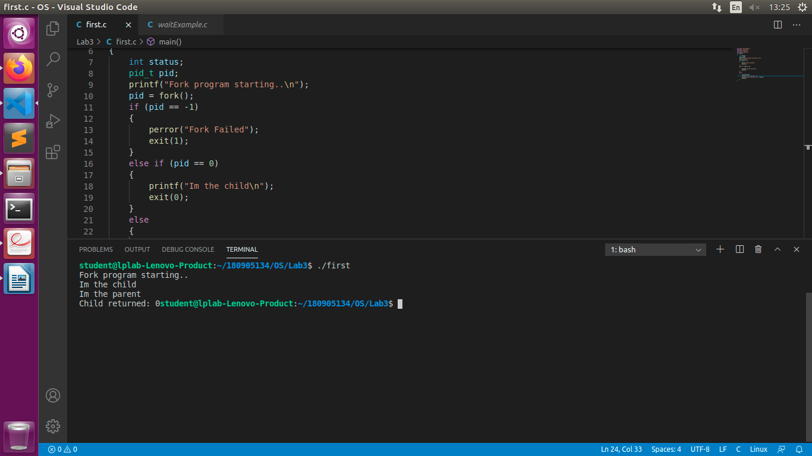

2. Load binary executable
#include <sys/types.h>
#include <sys/wait.h>
#include <unistd.h>
#include <stdio.h>
#include <stdlib.h>

void main()
{
int status;
pid_t pid;
pid = fork();
if (pid < 0)
{
printf("Child not created!\n");
exit(-1);
}
else if (pid == 0)
{
printf("Executing command!!!\n");
execlp("./first", "first", NULL);
}
else
{
wait(NULL);
printf("\nParent: Child completed\n");
exit(0);
}
}

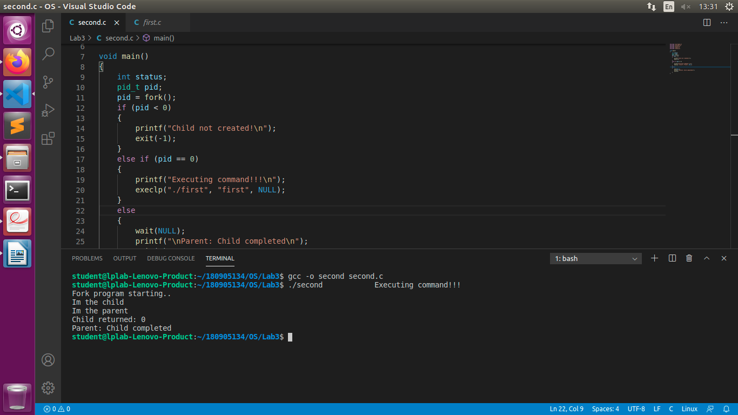
3. Parent and child’s pid
#include <sys/types.h>
#include <sys/wait.h>
#include <unistd.h>
#include <stdio.h>
#include <stdlib.h>

void main()
{
int status;
pid_t pid;
pid = fork();
if (pid == -1)
printf("Child not created!\n");
else if (pid == 0)
{
printf("Inside child process..\n\n");
pid_t parentPid = getppid();
pid_t childPid = getpid();
printf("PID of parent's child process: %d\n", childPid);
printf("PID of parent process: %d\n\n", parentPid);
}
else
{
wait(&status);
printf("Inside parent process..\n\n");
pid_t parentPid = getppid();
pid_t thisPid = getpid();
printf("PID of this process: %d\n", thisPid);
printf("PID of this parent's parent process: %d\n", parentPid);
exit(0);
}
}

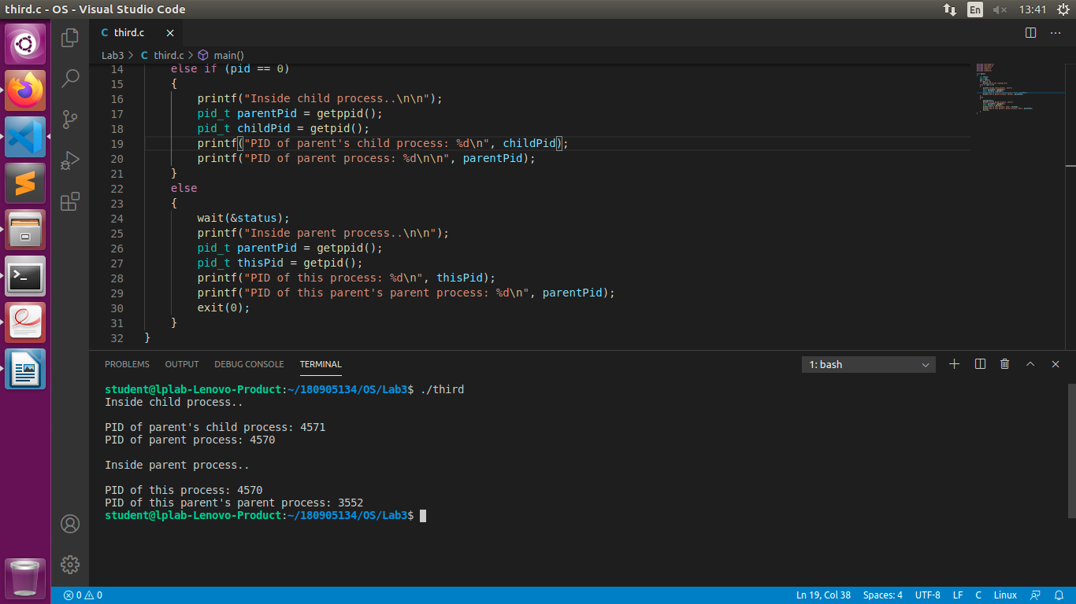
4. Zombie
#include <sys/types.h>
#include <sys/wait.h>
#include <unistd.h>
#include <stdio.h>
#include <stdlib.h>

void main()
{
int status;
pid_t pid;
pid = fork();
if (pid == -1)
printf("Child not created!!\n");
else if (pid == 0)
{
printf("Inside child process..\n\n%d", getpid());
exit(0);
}
else
{
printf("Inside parent process..%d\n\n", getpid());
while (1)
;
}
}
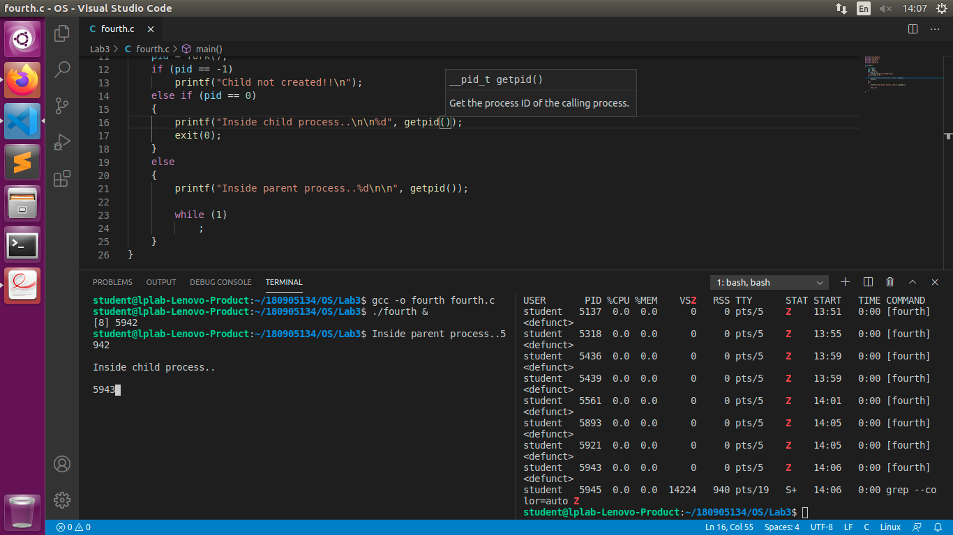
5. Orphan
#include <sys/types.h>
#include <sys/wait.h>
#include <unistd.h>
#include <stdio.h>
#include <stdlib.h>

void main()
{
int status;
pid_t pid;
pid = fork();
if (pid == -1)
printf("Child not created!!\n");
else if (pid == 0)
{
printf("Parents process id..\n\n%d", getppid());
sleep(5);
printf("Parents process id..\n\n%d", getppid());
}
else
{
printf("Inside parent process..%d\n\n", getpid());
exit(0);
}
}
